PCA - Varimax Rotation

User | Movie1_Toy-Story | Movie2_MonstersInc.
1 | 4 | 5
2 | 2 | 3
3 | 3 | 4
4 | 5 | 4
5 | 5 | 5
 | Mean = 3.8 | Mean= 4.2
 | Sdev= 1.303840481 | Sdev= 0.836660027

Standardize data:
User | Movie1_Toy-Story | Movie2_MonstersInc.
1 | 0.153392998 | 0.956182887
2 | -1.38053698 | -1.43427433
3 | -0.613571991 | -0.239045722
4 | 0.920357987 | -0.239045722
5 | 0.920357987 | 0.956182887
 | Mean =0 | Mean =0
 | Sdev = 1 | Sdev = 1

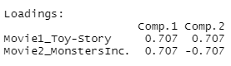
PC1 = 0.707* Movie1 + 0.707 Movie2
PC2 = 0.707* Movie1 + (-0.707 * Movie2)

we are going to select only PC1 with variance% of 86.6%
For PC1 the weights are as below
a1 = 0.707
a2 =0.707
as the signs are same it shows that Movie1 and Movie2 are positive correlated

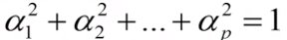
${0.707}^{2}+{0.707}^{2}$ = 1

Now calculate the Pearson correlation Coefficients to get the actual weights
Use the below formula:
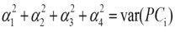
${0.707}^{2}+{0.707}^{2}$=var (PC1)
${0.707}^{2}+{0.707}^{2}$= 1.74

Therefore:
Loadings: Movie1 = 0.707 * $\sqrt{1.74}$ = 0.93
Loadings: Movie2 = 0.707 * $\sqrt{0.27}$= 0.36

Pearson correlation coefficients:
 | PC1 Loadings
Movie1 | 0.93
Movie2 | 0.36

Thus, means that standardize Movie1 data is correlated with 0.93 coefficient with PC1
And the Movie2 data is correlated with 0.36 coefficient with PC1

Varimax Rotation:
To understand Varimax rotation working let’s take the below dataset with 4 Movies:
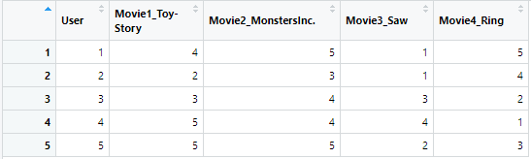

Standardize the data and perform PCA
Standardize data:
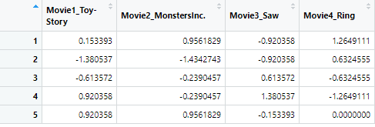

PCA and loadings/weights:
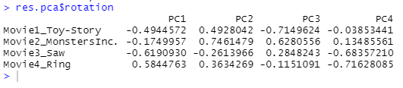
These are the loadings:
Now from above it is hard to tell which movie is loaded in which principal component
There are two ways to know about it. The one which we did above using Pearson Correlation Coefficient or using Varimax rotation.

Now check the cumulative variance first to decide how many components to be selected:
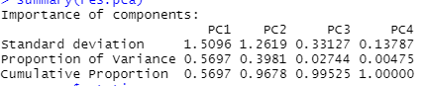

As with PC2 we reach up to 96.7% variance so we will select the first two components.

As varimax rotation is rotating the axis to get more clearer view of loadings of variables in each component.
Use R to perform PCA with varimax rotation. This can be done using psych package:

library(psych)
fit <- principal(Spcdf, nfactors=4, rotate="varimax")
fit # print results
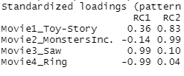
As seen from above the Movie3 and Movie4 are mostly loaded in RC1 (Component 1) and Movie1 and Movie2 are loaded in RC2 (Component 2).
Therefore, using varimax rotation it can be found out how each variable is being loaded into each Principal component.

